### cs370 program 2 FALL 2021

### Bennett Shoes is a small company that sells high end shoes and boots.

### Tyson Bennett, CEO has now asked you to write a detailed Employee Report for his Alabama stores. He wants to know how much it will cost him to give them a 5% raise. He has also been informed by his Insurance Provider in Alabama that the health and dental insurance premiums have increased by 2.5% and 1.5%. He would like totals for current salary, health insurance and dental insurance premiums. The Huntsville and Birmingham Alabama stores have had their information merged and stored in a file that is sorted in ascending order based on Store ID.

INPUT RECORD LAYOUT: 85-character record on disk – PR2F21-AL.txt

|  |  |  |  |  |
| --- | --- | --- | --- | --- |
| CC | Length | FIELD | DATA TYPE | RESTRICTIONS |
| 1-4 | 4 | Store ID | A | (BHAM, HUNT) |
| 5-9 | 5 | Employee ID | AN |  |
| 10-11 | 2 | Employee Position | A | (SM-Manager, SS-Supervisor, OW-Office, SA-Sales, SE-Security) |
| 12-21 | 10 | Employee Last Name | AN |  |
| 22-31 | 10 | Employee First Name | AN |  |
| 32 | 1 | Employee Middle Initial | AN |  |
| 35-42 | 8 | Hire Date | N |  |
| 43 | 1 | Employee Status | A | (C-current, M-Maternity Leave, V-Vacation, O-Other approved Leave, T-Terminated no rehire, E- Eligible for rehire) |
| 44-51 | 8 | Separation Date | N |  |
| 52-59 | 8 | Starting Yearly Salary | N | 2 Dec |
| 60-67 | 8 | Date of Last Pay Increase | N |  |
| 68-75 | 8 | Current Yearly Salary | N | 2 Dec |
| 76-77 | 2 | Number of Dependents | N |  |
| 78 | 1 | Health Plan | A | F – Family, S – Single, O – Opted Out |
| 79-81 | 3 | Health Ins Cost | N | Whole Dollars |
| 82 | 1 | Dental Plan | A | F – Family, S – Single, O – Opted Out |
| 83-85 | 3 | Dental Ins Cost | N | Whole Dollars |

OUTPUT REPORT: Follow the Printer Spacing Chart on next page.

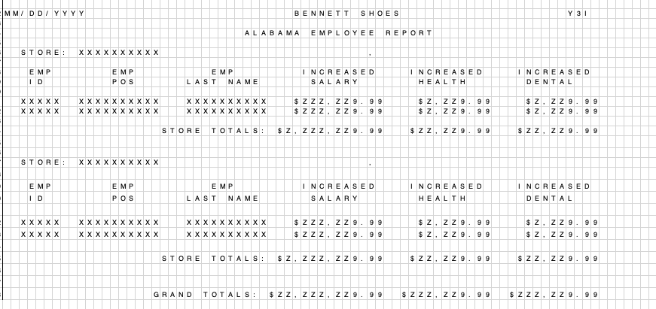

1. Group by Store ID – use an evaluate statement for the control break.
2. Expand Store Name by using an **IF** statement (HUNT – Huntsville, BHAM – Birmingham)
3. Expand the Position Code by using an EVALUATE statement (SM-Manager, SS-Supervisor, OW-Office, SA-Sales, SE-Security)
4. Employee’s salary is to be increased by 5%.
5. The Health Insurance Premiums have increased by 2.5%.
6. The Dental Insurance Premiums have increased by 1.5%.
7. For each store Total New Salary, New Health Insurance, New Dental Insurance
8. Grand Total New Salary, Grand Total New Health Insurance, Grand Total New Dental Insurance

*Hint1: To do the horizontal spacing count the squares and you will know how to code the line spacing across the page.*

*Hint2: Data Types X – Alphanumeric, 9 – Numeric, A – Alphabetic*

*Hint 3: Z is an editing symbol for zero suppression – Z in a field makes it Alphanumeric so that field cannot be used in a mathematical equation.*

*Hint4: The vertical line spacing between the lines is handled by how we send the information to the report file that we will create. DO NOT create a blank line for line spacing. You will be tempted to do this, but I will count off points.*